

**Data Technician**

|  |
| --- |
|  |

|  |
| --- |
| Name: |
| Course Date: |
|  |

**Table of contents**

Day 1: Task 1 3

Day 1: Task 2 3

Day 1: Task 3 4

Day 2: Task 1 5

Day 3: Task 1 9

Day 3: Task 2 10

Day 3: Task 3 11

Day 4: Task 1 12

Day 4: Task 2 13

1. Scenario Background 13

2. Data Laws and Regulations 14

3. Azure Service Recommendations 14

4. Data Types and Data Modelling 14

5. Data Storage Formats and Structures in Azure 14

6. Additional Considerations 15

Submission Guidelines: 15

Course Notes 17

Additional Information 17

# Day 1: Task 1

Please research and complete the below questions relating to key concepts of cloud.

Be prepared to discuss the below in the group following this task.

|  |  |
| --- | --- |
| What can cloud computing do for us in the real-world? | Cloud computing allows us to store data, process data, use applications, and access services, all remotely. This enables remote collaboration and data sharing between an unlimited number of people simultaneously. |
| How can it benefit a business? | Cloud computing can dramatically speed up access to data across the company, and give you access to tools that you otherwise would not be able to use on your own computer. |
| What’s the alternative to cloud computing? | The alternative is running applications and storing data on your own hardware, or your own servers. Also similarly decentralised storage solutions. |
| What cloud providers can we use, what are their features and functions? | The top three are Amazon’s AWS, Microsoft Azure, and Google GCP. They provide cloud storage, virtual machines, computing solutions, application platforms, and other services. |

# Day 1: Task 2

Please research the below cloud offerings, explain what they are and examples of use cases.

|  |  |  |
| --- | --- | --- |
| Cloud Offerings | Explain what it is | When / how might you use this service in the real-world? |
| IaaS (Infrastructure as a service) | IaaS is a cloud computing model that provides on-demand access to computing resources such as servers, storge, networking, and virtualisation. | This can be a more cost effective and flexible way of setting up your infrastructure, rather than investing in your own hardware and storage. |
| PaaS (Platform as a service) | PaaS is a complete cloud environment where developers can build, run, and manage applications. | This can be a powerful tool for dealing with application development, with everything you need in once place organised for you. |
| SaaS (Software as a service) | SaaS is a cloud software delivery model where users can access software over the internet rather than a local install. | This can save you valuable storage space on your device, and eliminates hardware restrictions while also giving you access to a much broader range of software than you would otherwise have. |

# Day 1: Task 3

Please research the below terms and explain what they are, when they would be appropriate and a real-world example of where it could be implemented (i.e. what type of organisation).

|  |  |
| --- | --- |
| Public Cloud | A Public Cloud is a cloud service hosted and managed by a third party, ie AWS, Microsoft Azure, or Google Cloud. This may be preferable for a very small company. |
| Private Cloud | A Private Cloud is a cloud service intended for use by a single organisation, managed either internally or by a third party. This could be used by a large organisation to maintain higher security. |
| Hybrid Cloud | A Hybrid Cloud has both public and private parts, allowing data to be shifted between them depending on the need and the load. |
| Community Cloud | A Community Cloud is a cloud service design for and used by multiple organisations within an area of industry or needs, ie hospitals. The service could comply to all medical data regulations, and be used by many unconnected medical practices. |

# Day 2: Task 1

Describe, with examples, the **three** major areas that the Computer Misuse Act deals with.

|  |  |  |
| --- | --- | --- |
| Area | Description | Example |
| Unauthorised access to computer material. | Gaining access to a computer without permission. | Guessing or bypassing someone's password to log into their account. |
| Unauthorised access with intent to commit or facilitate further crimes. | Using unauthorised access to commit fraud, theft, or other crimes. | Using unauthorised access to transfer money illegally. |
| Unauthorised acts with intent to impair, or recklessness as to impairing, operation of a computer. | Intentionally causing harm to computer systems or data. | Spreading viruses, malware, ransomware, launching DDoS attacks, or otherwise impairing the operation of a computer. |

The computer misuse act 1990 is an act where an individual can be criminalised because of computer related offense. Describe three extra powers that the Police and Justice Act 2006 (Computer Misuse) has added.

|  |
| --- |
| Description |
| Increased penalties for Hacking, including increased maximum prison sentence. |
| Denial of Service, or Distributed Denial of Service attacks added as a specific criminal offence. |
| Increased penalties for system damage, via malware or attacks, with Maximum sentence raised to 10 years. |

Look at the below website to answer the questions:

<https://www.gov.uk/personal-data-my-employer-can-keep-about-me>

|  |
| --- |
| Write down three items of data which a company can store about an employee. |
| * name * address * date of birth * sex * education and qualifications * work experience * National Insurance number * tax code * emergency contact details * employment history with the organisation * employment terms and conditions (for example, pay, hours of work, holidays, benefits, absence) * any accidents connected with work * any training taken * any disciplinary action |
|  |
|  |

|  |
| --- |
| Give three more examples of data that an employer can only store if they first get the employee’s permission. |
| * race and ethnicity * religion * political membership or opinions * trade union membership * genetics * biometrics, for example if your fingerprints are used for identification * health and medical conditions * sexual history or orientation |
|  |
|  |

Conduct further research to answer the below questions.

|  |  |
| --- | --- |
| Question | Answer |
| Provide one example of: Copyright infringement | Using someone's work without their permission for a public/commercial use, ie a song. |
| Provide one example of: Plagiarism | Passing off someone else's work as your own, ie a song. |
| What are two consequences of copyright infringement and software piracy? | Fines, lawsuits, criminal charges. |
| Give three possible consequences for individuals when using pirated software | Fines, lawsuits, criminal charges, also maybe malware. |

Listed below are some laws which we have covered today:

1. Computer Misuse Act 1990

2. Police and Justice Act 2006 (Computer Misuse)

3. Copyright, Designs and Patents Act 1988

4. Copyright (Computer Programs) Regulations 1992

5. The Health and Safety (Display Screen Equipment) Regulations 1992

6. Data Protection Act 2018

7. Consumer Rights Act 2015

* Insert a number in the first column of each row to match each of the statements with one of the above Acts.
* One of statements is incorrect and not illegal. For this statement, write ‘Not illegal’.

|  |  |
| --- | --- |
| **Act number** | **Clause** |
| 4 | With some exceptions, it is illegal to use unlicensed software |
| 7 | Any product, digital or otherwise, must be fit for the purpose it is supplied for |
| 1 | Unauthorised modification of computer material is illegal |
| Not Illegal | It is illegal to create or use a hacking tool for penetration testing |
| 6 | Personal data may only be used for specified, explicit purposes |
| 5 | Employers must provide their computer users with adequate health and safety training for any workstation they work at |
| 2 | It is illegal to distribute hacking tools for criminal purposes |
| 3 | It is illegal to distribute an illicit recording |
| 6 | Personal data may not be kept longer than necessary |
| 1 | Gaining unauthorised access to a computer system is illegal |
| 5 | Employers must ensure that employees take regular and adequate breaks from looking at their screens |
| 2 | It is illegal to prevent or hinder access (e.g. by a denial-of-service attack) to any program or data held in any computer |
| 6 | Personal data must be accurate and where necessary kept up to date |

# Day 3: Task 1

Please complete the below lab (3) *‘Explore relational data in Azure’* and paste evidence of the completed lab in the box provided.

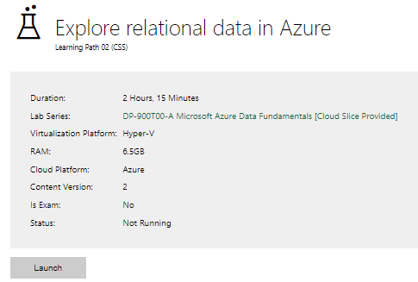

|  |  |
| --- | --- |
| Completed lab |  |

# Day 3: Task 2

Please complete the below lab (4) *‘Explore non-relational data in Azure’* and paste evidence of the completed lab in the box provided.

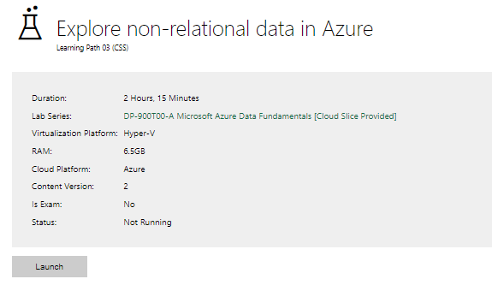

|  |  |
| --- | --- |
| Completed lab |  |

# Day 3: Task 3

Please complete the below lab (5) ‘Explore data analytics in Azure’ and paste evidence of the completed lab in the box provided.

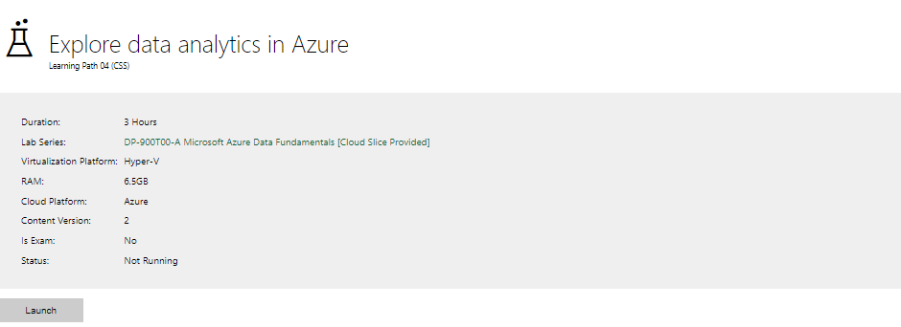

|  |  |
| --- | --- |
| Completed lab |  |

# Day 4: Task 1

In your teams, complete the Azure DP-900 practice exam and paste your result below – this is open book and please research and discuss your answers as a team.

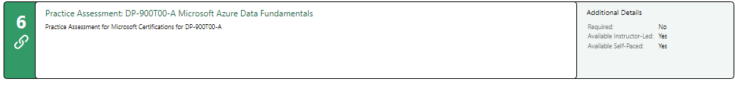

|  |  |
| --- | --- |
| Result | Attempted as an individual.  66, 72, 86 |

# Day 4: Task 2

#### **1. Scenario Background**

"Paws & Whiskers" is a growing pet shop that aims to improve its business by analysing sales, customer information, and inventory data. Currently, the data is collected manually or stored in spreadsheets. Management is interested in transitioning to Microsoft Azure to streamline data storage, analysis, and reporting, enabling them to make data-driven decisions.

#### **2. Data Laws and Regulations**

Identify and explain the data laws and regulations relevant to handling customer data within the proposal. Ensure you cover the following points:

* **GDPR Compliance**: Highlight the importance of adhering to the General Data Protection Regulation (GDPR), particularly as it relates to storing and processing customer information.
* **Data Protection Act (DPA) 2018**: Outline how the DPA 2018 may affect the way "Paws & Whiskers" collects and stores data, ensuring compliance with UK laws on data privacy.
* **Other Industry Standards**: Research any additional data protection standards or regulations that may apply to pet shop data, particularly if they involve sensitive or payment information.

#### **3. Azure Service Recommendations**

Recommend Microsoft Azure services that would suit the company’s data analysis needs and explain why these services are suitable. Your recommendations should include:

* **Data Storage**: Identify suitable storage options, such as **Azure Blob Storage** or **Azure SQL Database**, and discuss the benefits of each for storing large datasets, including inventory, sales transactions, and customer details.
* **Data Analysis Tools**: Recommend tools such as **Azure Machine Learning** for customer behaviour analysis or **Azure Synapse Analytics** for analysing sales trends.
* **Data Integration and Automation**: Explain how services like **Azure Data Factory** could automate data collection and integration processes, improving efficiency.

#### **4. Data Types and Data Modelling**

Define the types of data "Paws & Whiskers" will need to work with and describe your approach to data modelling:

* **Data Categories**: Identify key data types, such as customer demographics, transaction history, pet inventory, and product categories.
* **Data Modelling Approach**: Outline how you would structure this data using a relational model or a data warehouse approach, considering factors like tables, entities, relationships, and primary keys.

#### **5. Data Storage Formats and Structures in Azure**

Discuss how you would store data within Azure and the formats you would recommend:

* **Data Formats**: Specify recommended formats (e.g., CSV for raw data imports, JSON for structured data, Parquet for analytics) and explain why these formats are suitable for specific data types.
* **Data Security and Encryption**: Include recommendations for securing data using Azure’s built-in encryption features and access controls to ensure compliance with data privacy regulations.

#### **6. Additional Considerations**

Provide any other considerations that might enhance data handling and efficiency in Azure, such as:

* **Backup and Disaster Recovery**: Outline a backup plan using **Azure Backup** or **Azure Site Recovery** to safeguard against data loss.
* **Data Visualisation**: Discuss potential use of **Power BI** within Azure for creating dashboards that provide management with real-time insights into sales and customer trends.
* **Future Scalability**: Comment on how Azure services can scale as the business grows, accommodating larger datasets and more complex analyses.

### **Submission Guidelines:**

1. **Structure**: Ensure your report is well-organised, with sections for each task (e.g., Data Laws, Azure Services, Data Types, etc.).
2. **Formatting**: Include headings, bullet points where appropriate, and any visuals or diagrams that support your explanations.
3. **References**: Cite any resources or regulations referenced in the report.
4. **Length**: Aim for 1500-2000 words.

|  |
| --- |
| * May attempt this at a later date. |

|  |
| --- |
| **Course Notes** |

It is recommended to take notes from the course, use the space below to do so, or use the revision guide shared with the class:

|  |
| --- |
| **Additional Information** |

We have included a range of additional links to further resources and information that you may find useful, these can be found within your revision guide.

**END OF WORKBOOK**

**Please check through your work thoroughly before submitting and update the table of contents if required.**

**Please send your completed work booklet to your trainer.**